
a
Company
Logotype

Cone Beam Computed Tomography- Report



Porur Dental X-rays & CBCT

Patient Name : Miss. Elakiya | Date of Report : 23.04.2024
Age/ Gender : 27 years/ Male | Region of Interest : CBCT Full Skull
Referring doctor: Dr. Boominathan | Indication : Implant assessment
Clinical Notes: Nil
PATIENT INFORMATION

CBCT- Full Skull provided
CBCT – IMAGE DETAILS

RADIOGRAPHIC INTERPRETATION

- Completely missing crown and root portion in relation to: 36, 38, 48.
- Presence of a hyperdense screw like structure within the alveolar region in relation to 46 region is evident.
- The maxillary alveolar ridge is present with normal trabecular pattern.
- Crown in relation to 14, 15, 17, 27, 35, 37, 46.
- Root stumps in relation to 16.

 | 16 region | 26 region
Sub-Crestal (in mm) | 9.5 | 9.5
Mid- Crestal (in mm) | 9.7 | 9.2
Distance between the alveolar ridge and floor of the maxillary sinus (in mm) | 3.7 | 6.9
 | 36 region
Sub-Crestal (in mm) | 5.6
Mid- Crestal (in mm) | 8.9
Distance between alveolar ridge and the inferior alveolar nerve canal (in mm) | 17.4
Distance between alveolar ridge and the inferior border of mandible (in mm) | 25.3
IMPLANT ASSESSMENT

RADIOGRAPHIC IMPRESSION

- Partially edentulous maxillary arch.
- Implant in relation to 46.
- Root stumps: 16.
- Crown in relation to 14, 15, 17, 27, 35, 37, 46.

Kindly correlate with clinical findings


IMAGES FOR REFERENCE

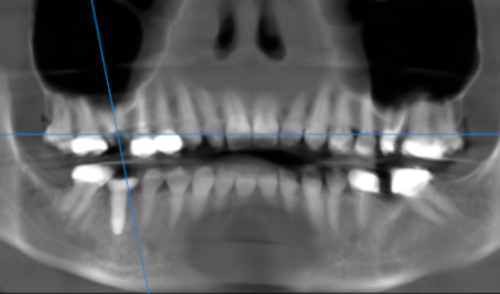

3-DIMENSIONAL VIEW

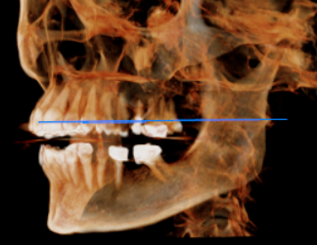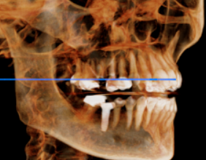

CROSS SECTIONAL VIEW

16 region | 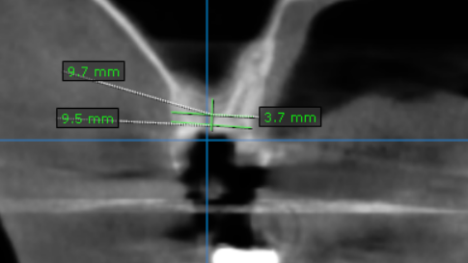
26 region | 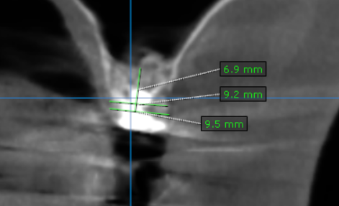
36 region | 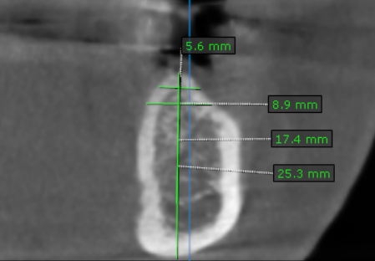

**** End of report ****

